

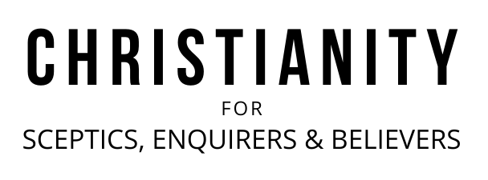

A very warm welcome
Chris Fishlock is speaking on Philippians 3:12-4:1

Notices

1. New? If you’re here for the first time and would like more information about St Nick’s Talks, including our weekly email, please fill in a contact card or visit: www.stnickstalks.org/new.

2. St Nick’s Talks Partnership. A weekly opportunity to discuss what we’ve been learning and pray for gospel ministry in the City. Monday Lunchtimes and Tuesday mornings at St Nick’s church. Email sophie@snca.co.uk for more details.

3. Listen again. Missed a recent talk? Catch-up via Spotify. Just search for the St Nick’s Talks.

Talk recordings & info | www.stnickstalks.org
Living With an Eternal Focus Philippians 3:12 - 4:1 Page 981
Grown-up Christian Thinking

- Restless - because we are not home yet (v12a)

- Forget what lies behind

- Focus on to the prize ahead

- Follow other mature Christians

- Content - because Jesus has secured our future (v12b)

- We belong to Jesus

- We are citizens of heaven

Application: Restless contentment

Questions:
1. Minds set on earthly things: what would that look like and where are Christians in danger of earthly thinking?
2. What might ‘restless contentment’ look like for you?

A very warm welcome
Chris Fishlock is speaking on Philippians 3:12-4:1

Notices

1. New? If you’re here for the first time and would like more information about St Nick’s Talks, including our weekly email, please fill in a contact card or visit: www.stnickstalks.org/new.

2. St Nick’s Talks Partnership. A weekly opportunity to discuss what we’ve been learning and pray for gospel ministry in the City. Monday Lunchtimes and Tuesday mornings at St Nick’s church. Email sophie@snca.co.uk for more details.

3. Listen again. Missed a recent talk? Catch-up via Spotify. Just search for the St Nick’s Talks.

Talk recordings & info | www.stnickstalks.org
Living With an Eternal Focus Philippians 3:12 - 4:1 Page 981
Grown-up Christian Thinking

- Restless - because we are not home yet (v12a)

- Forget what lies behind

- Focus on to the prize ahead

- Follow other mature Christians

- Content - because Jesus has secured our future (v12b)

- We belong to Jesus

- We are citizens of heaven

Application: Restless contentment

Questions:
1. Minds set on earthly things: what would that look like and where are Christians in danger of earthly thinking?
2. What might ‘restless contentment’ look like for you?

