

A very warm welcome
Sunday 2nd October 2022

What to Expect:
Welcome - Tom Wright
Song - By Faith
Song - O Lord, My Rock and My Redeemer
Confession
Prayers - Suzie Normanton
Notices & Break
Song - See The Man
Reading - Christian Stuart
Sermon - Exodus 1:1-2:10, Chris Fishlock
Song - Our God Reigns
Final Words

Children: We’re committed to helping all ages know Jesus better so we run age-appropriate groups.
Speak to a staff member or email Mikey: mikey@snca.co.uk

Photography and Filming: Our service is being live streamed. You may feature if you’re in shot of the camera at the back. We may also take photos for our website and social media. Please speak to a steward if you would rather not feature.
Notices
1. Welcome. Especially if you are new! Please fill in a ‘tell me more’ contact card at the back.

2. Wine tasting! Sign up and invite your friends for an evening of wine tasting, cheese and a bible talk explaining what we're all about at St Nick's.
Tuesday 1st November at St Nick’s church.
Tickets: £10 Booking essential - scan the QR code or visit our website.
3. Small Groups. Please join us on Wednesday for our church family’s Small Group Bible study. Bring food to eat together from 6.15pm, Bible study in John’s Gospel from 7pm.
4. Gospel at Work. New to London? Find your nearest Lunchtime Talk by speaking to someone on the staff team or visiting https://www.gospelatwork.org.uk/map.
Talk Recordings & Info: www.stnickschurch.org.uk | Spotify ‘St Nick’s Church’

Exodus: Know That I am the Lord (1) Exodus 1:1 - 2:10 Page 43
Introduction:

- Background: God makes promises (1:1-7)

Link with Genesis (God’s promise to Abraham
Many PEOPLE; into LAND; under good RULE & richly BLESSED)

- Foreground: The world rages against God’s promises (1:8-22)

- Background: God keeps his promises (2:1-25)

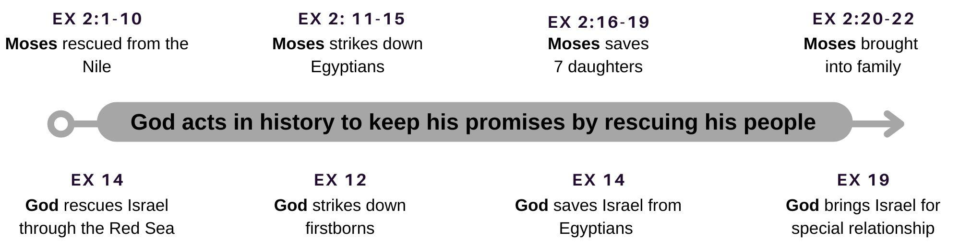

Application: Daily ‘healthy fear’ of a good & faithful God

- Look at the midwives (1:15-21)

Questions for discussion.
- In what ways do we see the world raging against God’s promises today?
- What would a healthy fear of this Lord God look like on Monday morning as you walk into your school / office?

