



A very warm welcome
Our speaker today is Chris Fishlock
Our passage is Haggai 1:1-15

Notices

1. New? If you’re here for the first time and would like more information about the London Bridge Talks, including our weekly email, please fill in a contact card or visit: www.londonbridgetalks.org/new.

2. Partnership. A weekly opportunity to discuss with others how what we’re hearing applies to life in the City. Email tom.wright@snca.co.uk for details.

3. Christianity Explored. A three-week course designed to introduce people to the central claims of Jesus. Begins Wednesday 11th January, 7pm-8pm at St Nick’s Church. Visit our website for more information.

Talk recordings & info | www.londonbridgetalks.org
God’s Building Project (1) Haggai 1:1-15 Page 791
Introduction: An audit of how you spend your time

Finding our bearings in the book of Haggai

Timeline

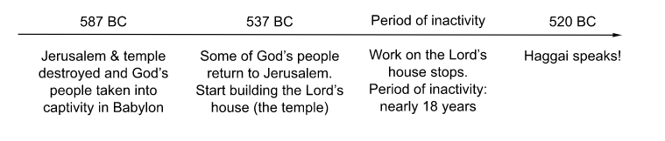

- A busy life of exams, kitchen improvements, loft extensions, appraisals, investment choices, car loans, head-hunted and paying off the mortgage (to name a few)….

- A gracious wake up call

- A life that pleases God

Questions:
i) How does the Lord get his people to prioritise building his house?
ii) What does building the Lord’s house mean today?
iii) “Consider your ways”: What matters most in your life?

A very warm welcome
Our speaker today is Chris Fishlock
Our passage is Haggai 1:1-15

Notices

1. New? If you’re here for the first time and would like more information about the London Bridge Talks, including our weekly email, please fill in a contact card or visit: www.londonbridgetalks.org/new.

2. Partnership. A weekly opportunity to discuss with others how what we’re hearing applies to life in the City. Email tom.wright@snca.co.uk for details.

3. Christianity Explored. A three-week course designed to introduce people to the central claims of Jesus. Begins Wednesday 11th January, 7pm-8pm at St Nick’s Church. Visit our website for more information.

Talk recordings & info | www.londonbridgetalks.org
God’s Building Project (1) Haggai 1:1-15 Page 791
Introduction: An audit of how you spend your time

Finding our bearings in the book of Haggai

Timeline

- A busy life of exams, kitchen improvements, loft extensions, appraisals, investment choices, car loans, head-hunted and paying off the mortgage (to name a few)….

- A gracious wake up call

- A life that pleases God

Questions:
i) How does the Lord get his people to prioritise building his house?
ii) What does building the Lord’s house mean today?
iii) “Consider your ways”: What matters most in your life?

