

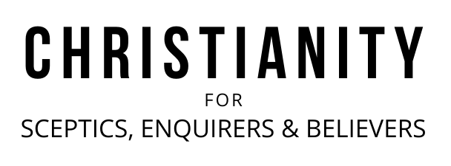

A very warm welcome
Our speaker today is Chris Fishlock
Our passage is 2:10-19

Notices

1. New? If you’re here for the first time and would like more information about the London Bridge Talks, including our weekly email, please fill in a contact card or visit: www.londonbridgetalks.org/new.

2. Partnership. A weekly opportunity to discuss with others how what we’re hearing applies to life in the City. Email tom.wright@snca.co.uk for details.

3. Did Darwin make atheism credible? Join us for a talk and Q&A with evolutionary biologist Professor Richard Buggs. Tuesday 7th February at St Nick’s Church, welcome drinks from 6.15pm, talk and Q&A 7pm-8pm. Why not invite friends and colleagues to come along?

Talk recordings & info | www.londonbridgetalks.org
God’s Building Project (3) Haggai 2:10-19 Page 791
Introduction

- Our inability to please God with what we do (v10-14)

Holiness can’t be transferred

Uncleanness can be transferred

- God’s Grace (v15-19)

Questions:
- How easy it is to start to rely upon our own strength and ability. Why is this dangerous?
- How does this passage help us to understand God’s grace? Why is that important?

A very warm welcome
Our speaker today is Chris Fishlock
Our passage is 2:10-19

Notices

1. New? If you’re here for the first time and would like more information about the London Bridge Talks, including our weekly email, please fill in a contact card or visit: www.londonbridgetalks.org/new.

2. Partnership. A weekly opportunity to discuss with others how what we’re hearing applies to life in the City. Email tom.wright@snca.co.uk for details.

3. Did Darwin make atheism credible? Join us for a talk and Q&A with evolutionary biologist Professor Richard Buggs. Tuesday 7th February at St Nick’s Church, welcome drinks from 6.15pm, talk and Q&A 7pm-8pm. Why not invite friends and colleagues to come along?

Talk recordings & info | www.londonbridgetalks.org
God’s Building Project (3) Haggai 2:10-19 Page 791
Introduction

- Our inability to please God with what we do (v10-14)

Holiness can’t be transferred

Uncleanness can be transferred

- God’s Grace (v15-19)

Questions:
- How easy it is to start to rely upon our own strength and ability. Why is this dangerous?
- How does this passage help us to understand God’s grace? Why is that important?

