

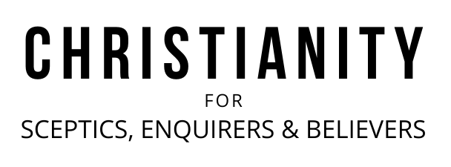

A very warm welcome
Our speaker today is Chris Fishlock
Our passage is 2:20-23

Notices

1. New? If you’re here for the first time and would like more information about the London Bridge Talks, including our weekly email, please fill in a contact card or visit: www.londonbridgetalks.org/new.

2. Partnership. A weekly opportunity to discuss with others how what we’re hearing applies to life in the City. Email tom.wright@snca.co.uk for details.


3. Did Darwin make atheism credible? Join us for a talk and Q&A with evolutionary biologist Professor Richard Buggs. Tuesday 7th February at St Nick’s Church, welcome drinks from 6.15pm, talk and Q&A 7pm-8pm. Scan the QR code to register your interest.

Talk recordings & info | www.londonbridgetalks.org
God’s Building Project (4) Haggai 2:20-23 Page 792
Introduction

- All kingdoms of this world face ruin (v20-22)

- Imminent – about to happen

- God’s king will be established (v23)

Application:

How will the next event in God’s diary shape the way you use your time?

- Have you taken refuge?

- Build the Lord’s house - beware of competing building projects

- Build the Lord’s house – don’t let apparent insignificance fool you

Questions:
- What exactly does it mean to be building the Lord’s house today? Why is that so important in light of Haggai 2:20-23?
- How has this final section helped to provide focus to my life and activity?

A very warm welcome
Our speaker today is Chris Fishlock
Our passage is 2:20-23

Notices

1. New? If you’re here for the first time and would like more information about the London Bridge Talks, including our weekly email, please fill in a contact card or visit: www.londonbridgetalks.org/new.

2. Partnership. A weekly opportunity to discuss with others how what we’re hearing applies to life in the City. Email tom.wright@snca.co.uk for details.

3. Did Darwin make atheism credible? Join us for a talk and Q&A with evolutionary biologist Professor Richard Buggs. Tuesday 7th February at St Nick’s Church, welcome drinks from 6.15pm, talk and Q&A 7pm-8pm. Scan the QR code to register your interest.

Talk recordings & info | www.londonbridgetalks.org
God’s Building Project (4) Haggai 2:20-23 Page 792
Introduction

- All kingdoms of this world face ruin (v20-22)

- Imminent – about to happen

- God’s king will be established (v23)

Application:

How will the next event in God’s diary shape the way you use your time?

- Have you taken refuge?

- Build the Lord’s house - beware of competing building projects

- Build the Lord’s house – don’t let apparent insignificance fool you

Questions:
- What exactly does it mean to be building the Lord’s house today? Why is that so important in light of Haggai 2:20-23?
- How has this final section helped to provide focus to my life and activity?

